**Programing Lab-3-ESE**

Name:- Aryan Sagar

Prn:- 21510117

Batch:- T1

**Q) Design Website for Technical Blog with which include Homepage, at least 3 article pages with images, rating and comment . Link all pages using navigation bar. Use html and CSS for styling . Host website on any free web hosting services.**

**Tech Stack Used:- Html, CSS**

**Homepage:-**

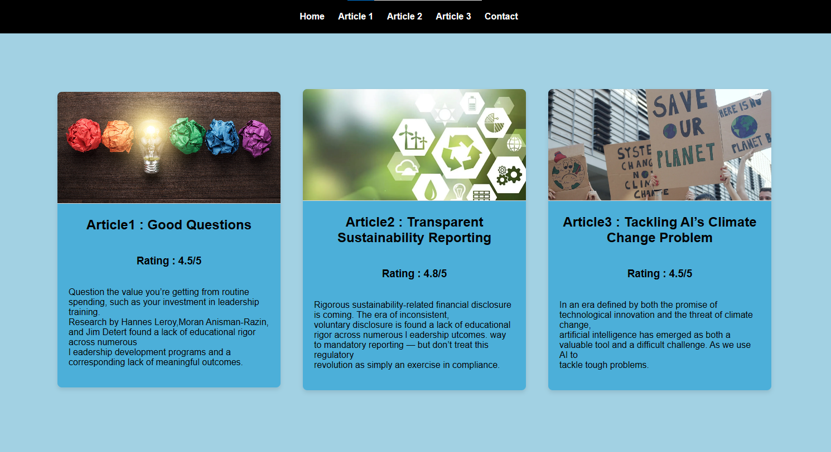

**Contact us page:-**

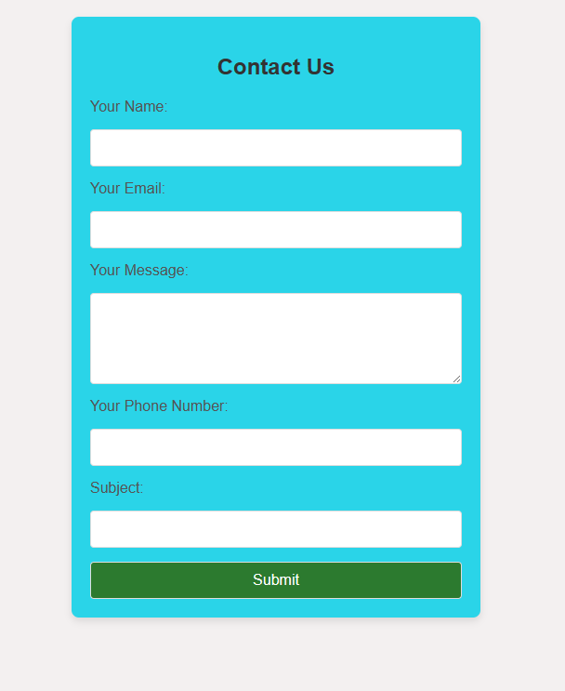

**Article1- page**

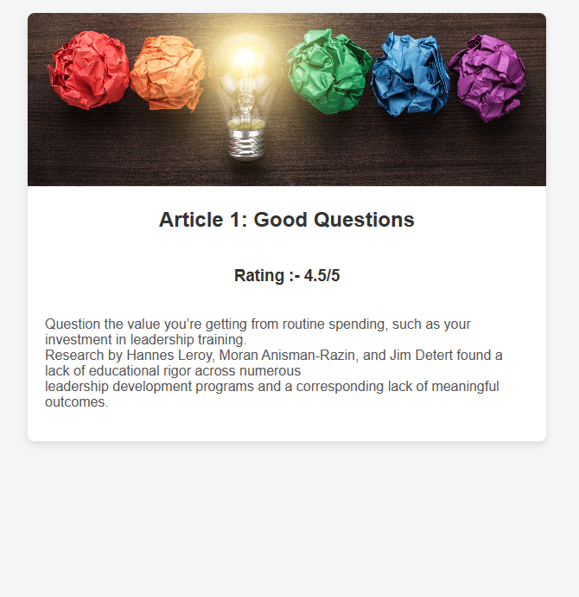

**Article2-page**

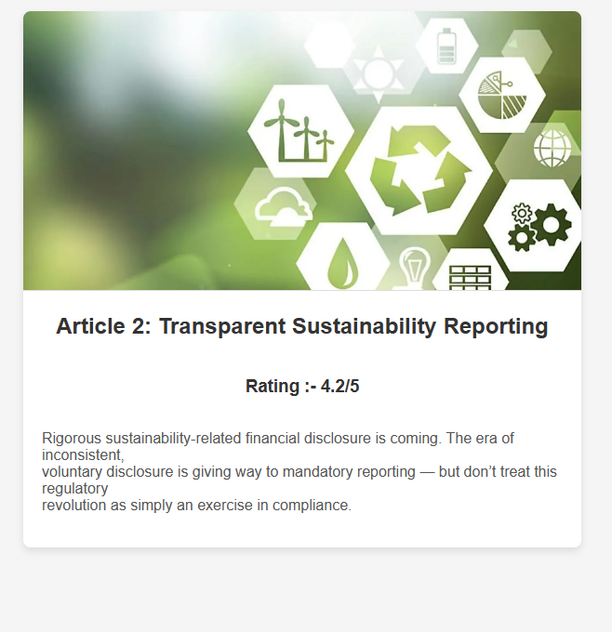

**Article3-page**

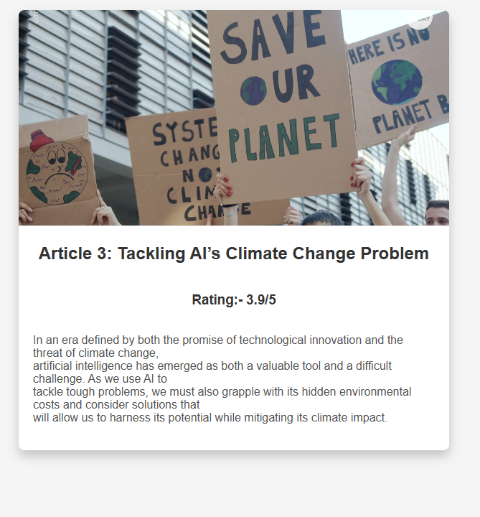

**Website-Host on Netlify:-**

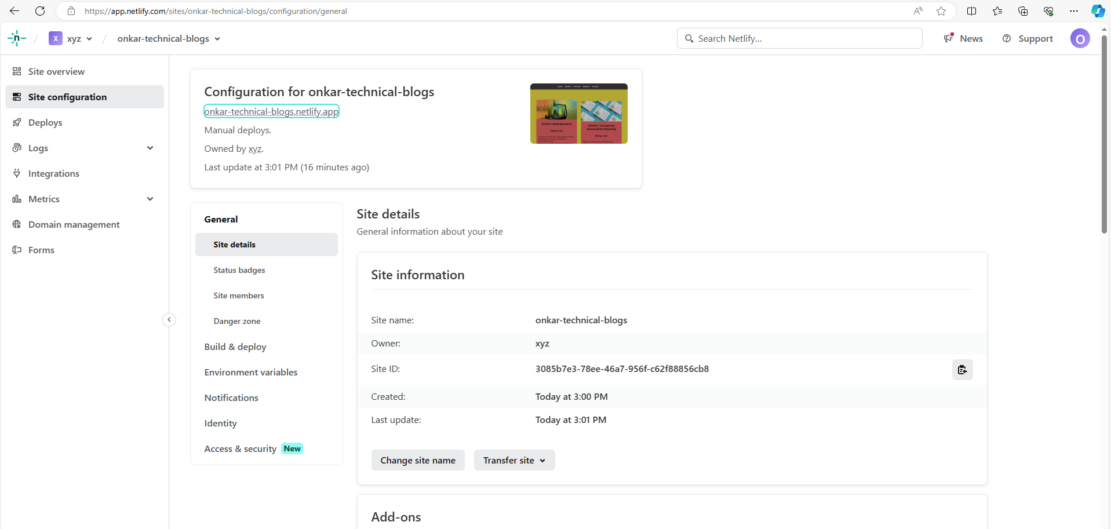

Link of website:- [Technical Blog (aryan-technical-blogs.netlify.app)](https://onkar-technical-blogs.netlify.app/)

